**Name: PARAS RATHI**

**Roll No: BIT-24S-007**

**LAB: 01**

**Task 1:**

Make 2-2 programs of each datatype.

* **NUMERIC TYPES:**
* **Integer:**

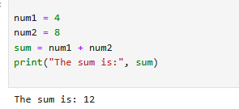

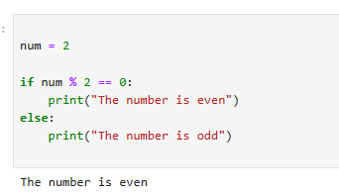

* **Float:**

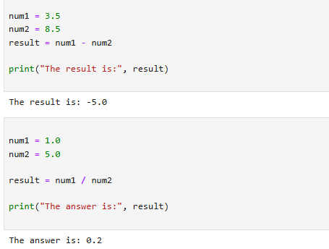

* **Complex:**

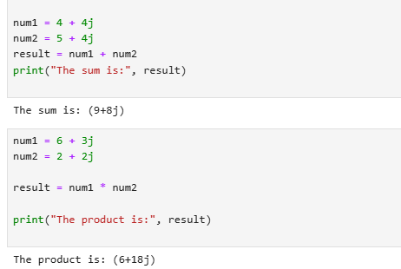

* **SEQUENCE TYPES:**
* **String**

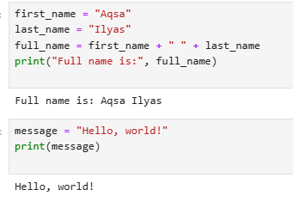

* **List:**

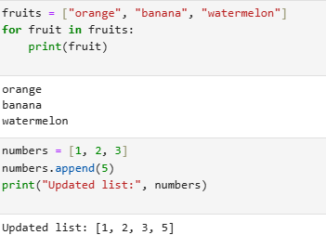

* **Tuple:**

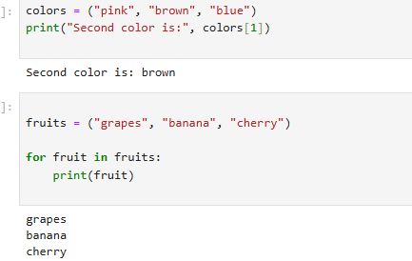

* **Range:**

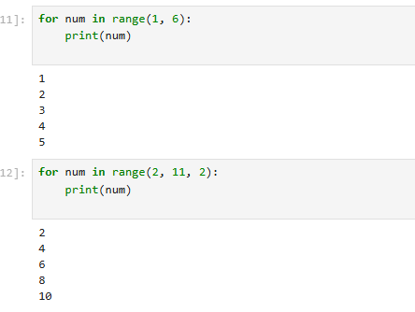

* **SET TYPES:**
* **Set:**

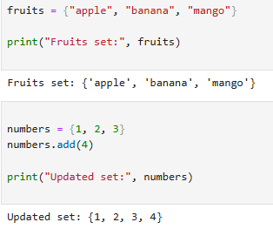

* **Frozen set:**

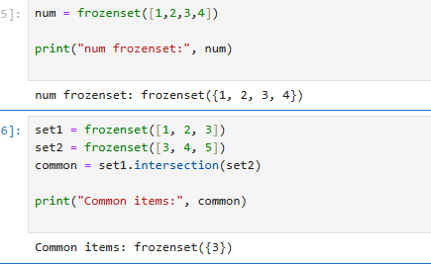

* **MAPPING TYPE:**
* **Dictionary dict:**

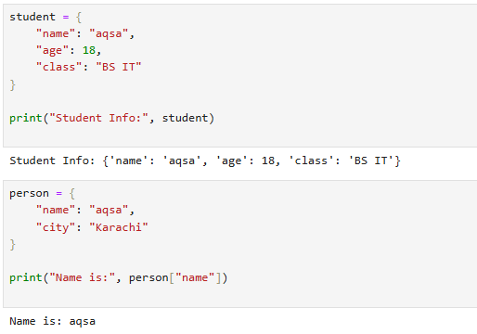

* **BOLEAN TYPE:**

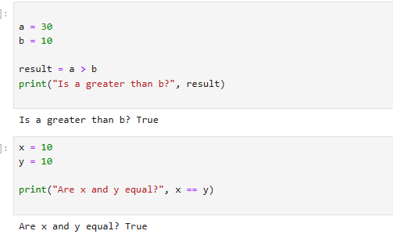

**Task 2:**

**Make up to 5 shapes programs using \***

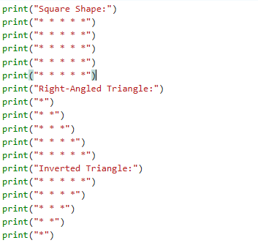

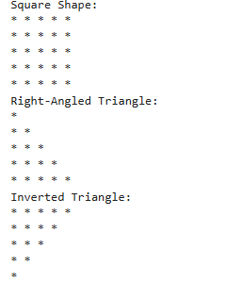

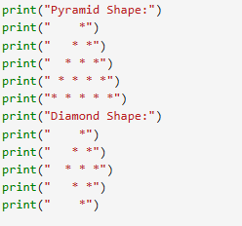

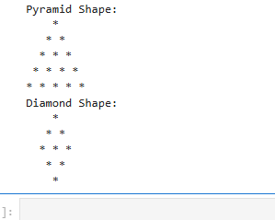

**Task 3:**

Make same shapes you have made in task 2, using * multiple by number.

**Program:**

